

Pinchmill Primary School

The Old Road, Felmersham, Bedfordshire MK43 7JD

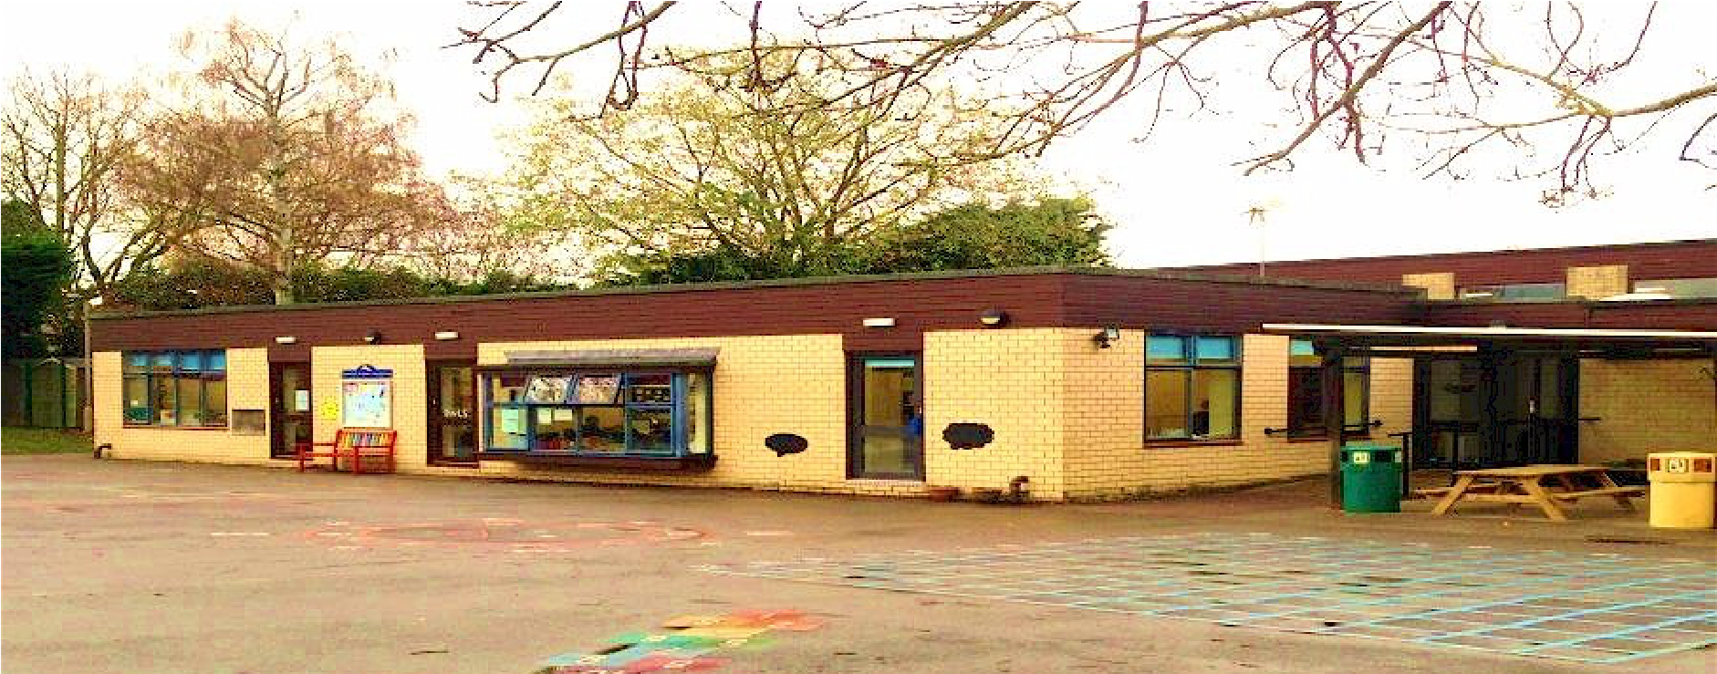

Admissions Policy

Date of Review | January 2026
Next Review Date | January 2027
Staff Responsibility | Head
Responsibility FGB/Committee | FGB
Governor Approval

Introduction

Pinchmill Primary School is a 105 place Foundation Status School catering for children within the 4+ to age 11 range. The Governors will admit up to 15 children to the Reception Class in each academic year.

The Governing Body, being the admissions authority, determines the school admissions policy and arrangements and is responsible for taking decisions on applications for admissions. The Governing Body works with the Local Authority to ensure that admissions are co-ordinated within the Borough.

Method of allocation of Reception Class Places
In the event of there being more applications than there are places available, the Governors will apply the following criteria in the priority order of categories as listed.

- Previous ‘looked after’ and current `looked after` children (see definition).

- Children living within the parishes of Felmersham, Radwell and Pavenham, with siblings at the school (see definition of sibling)

- Other children living within the parishes of Felmersham, Radwell and Pavenham

- Other siblings (see definition).

- On very exceptional medical grounds (see definitions).

- Any other children.

NOTES
If applying these criteria results in there being more children with an equal right to admission to the school than the number of available places, the tie break will be the distance the pupil lives from the school, measured in a straight line, using the Local Authority’s computerised mapping system, with those living closer to the school receiving the higher priority. The distance will be measured from the address point of the pupil’s home to the main entrance of the school. Priority will not be given within each criterion to children who meet other criteria.

The Local Authority will normally offer a place at the catchment area school if parents apply for a place at the school during the normal admissions round. However, a place at the catchment area school cannot be guaranteed. If a pupil moves into the catchment area outside the normal admissions round (or after the allocation process has begun) it may be more difficult to offer a place at the catchment area school if this would mean exceeding the admission number at the school. In this case, a place will normally be offered at the next nearest maintained school which caters for pupils of the same age and has places available.

Pupils who have a Statement of Special Educational Needs are required to be admitted to the school which is named on the statement, even if the school is full. Pupils identified for admission through the Fair Access Protocol will also be admitted even if the school is full.

Definitions

'Looked after' children
A ‘looked after’ child is a child who is (a) in the care of the local authority, or (b) being provided with accommodation by a local authority in the exercise of their social services functions (see Section 22(1) of the Children Act 1989).

Previously ‘looked after’ children
A previously ‘looked after’ child is one who immediately after being ‘looked after’ became subject to an adoption, residence, or special guardianship order. An ‘adoption order’ is an order under section 46 of the Adoption and Children Act 2002. A ‘residence order’ is an order settling the arrangements to be made as to the person with whom the child is to live under section 8 of the Children Act 1989. Section 14A of the Children Act 1989 defines a ‘special guardianship order’ as an order appointing one or more individuals to be a child’s special guardian (or special guardians).

Sibling
A sibling refers to a brother or sister, half brother or sister, adopted brother or sister, step-brother or step-sister or the child of the parent/carer’s partner, and in every case, the child should be living at the same address. The sibling must be in school at the same time as the application and be likely to remain in the school at the proposed date of admission.

‘Very Exceptional’ Medical Grounds
‘Very exceptional’ medical grounds refers to cases where there are exceptional medical reasons which make it essential that a child should attend a particular school and where the preferred school is the only school locally that could meet the child’s needs. A medical report from the child’s doctor or consultant must be submitted with the application form, setting out valid medical reasons why it is essential for the child to be admitted to the school in question and the difficulties that would be caused if the child had to attend another school. The comments of the Authority’s medical officer may be sought to decide whether it is essential for a child to be admitted to the preferred school on medical grounds. Admission on medical grounds cannot be considered where the medical condition relates to that of a parent/carer, brother or sister or another relative/childminder.

Home Address
A pupil’s home address will be regarded as the address of the parent/carer with parental responsibility with whom the child normally lives. This will not usually include grandparents, aunts or uncles. Where a child spends time with parents/carers at more than one address, the address used to allocate a school place will be the one at which the pupil is ordinarily resident and where the child spends the majority of the school week (Mondays to Fridays) including nights. If there is any query on the home address this will be checked against original documentation e.g. council tax bill, a recent utility bill (gas, electricity or water), a rental agreement, child benefit annual statement or family tax credit information.

Admission into the Reception Class

Children are admitted to our Reception Class in the September following their fourth birthday. All children can be admitted on a full-time basis from September, although there is no obligation to send your child to school full-time if you feel that it would not be in their best interest, this should be discussed with the school on an individual basis. However, once your child reaches statutory school age (five years), full-time attendance is compulsory.

The Local Authority administers all applications for admission into the school each September (statutory applications). Applications into the school for September 2027 (birthdays between 1st September 2021 and 31st August 2022), must be with the Admissions Service at Borough Hall no later than 15th January 2027. An application form will need to be completed for each child in the family. Parents will be notified in writing by Bedford Borough Council if they have been allocated a place in the Reception Class for September 2024.

In Year Admissions

In the case of older children who apply to join the school, admission will be on the basis of places being available in the relevant year group. Requests for admission into other year groups should be made directly to the school, and on the In-Year application form available from the school. If there are more applicants for places than available, then the above Admissions criteria will apply.

Appeals/Waiting Lists

Parents of pupils not offered a place at the school will have the right of appeal to an independent Admissions Appeal Panel and will receive an appeal form with the refusal letter. The appeal should be returned to the Clerk of the Appeals panel in Committee Services at Borough Hall. (Tel: 01234 228905) or for information http://www.bedford.gov.uk/appeals

Any child refused a place at the school will be placed on a waiting list which will be prioritised according to the admissions criteria. Waiting lists for the normal year of entry will be maintained until the end of the Autumn term.

Further information is available at: www.bedford.gov.uk/admissions

If you wish to make any comments about our Admissions Policy please contact Mrs Bailey, Head Teacher,
Pinchmill Primary School, The Old Road, Felmersham, Bedford, MK43 7JD, 01234 781371

