Phonics | Group A will be review sounds taught in Reception.  Group B will be reviewing sounds taught at the end of Year 1.
Reading | We will continue to read ‘Super Daisy,’ we are going to explore key vocabulary, make a prediction make connections and answer questions.
Writing | We will be hooked into our new story of ‘Handa’s hen’. We will be exploring what an adventure story is and looking at expanded noun phrases.
Maths | We will be working out one more and one less of numbers and working out greater and less than.
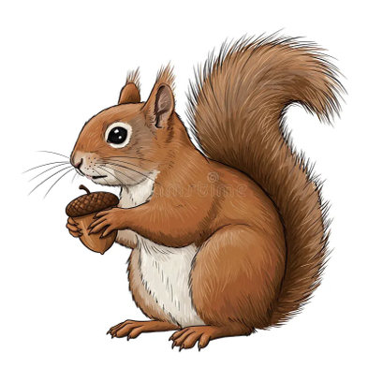
Squirrel’s weekly focus

