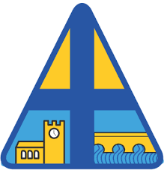

Curriculum Overview
Year Three and Four
Autumn Term 1
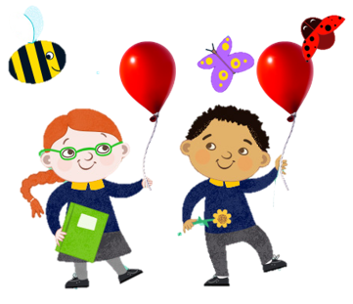

Miss Dowd


Reading:
During our daily whole class reading lessons, children will develop their inference, prediction, explaining, retrieving, sequencing/summarising skills as well as broadening their vocabulary. Our first unit focuses on the text ‘Who Let the Gods Out?’ by Maz Evans. We look forward to reading about how Elliot overcomes the challenges ahead.

Writing:

For our Writing we will be following a scheme written by Jane Considine, called ‘The Write Stuff.’ In our first half term we will be building our skills to write a variety of text types, based on the text ‘Beasts of Olympus’ by Lucy Coats. During each writing lesson we will also have time to focus on our grammar skills. For our first writing outcome we will be using adverbs, fronted adverbials, similes and descriptive language to describe characters and the setting.
Specific stand-alone spelling and handwriting lessons continue to form part of our English timetable to develop understanding of spelling rules, improving our letter formation and handwriting skills, where we will be developing consistency in letter size, fluency in writing and finding our own handwriting style. We aim to continue to practice our common exception words to ensure the children have access to reach their age related expectations for writing.

Mathematics:
We will be following the White Rose Maths scheme of learning for Mathematics. We will begin by looking at place value, where the children can practise their understanding of what each digit represents. We will then move on to addition and subtraction. These can be two tricky units and we encourage you to support at home with the weekly Maths homework and by reading the note home with information and support. Much challenge will be offered and we encourage the use of BBC Bitesize, Maths Frame and https://www.timestables.co.uk/ where you will find videos and activities to support your children’s learning. Year 4 have a times table test near the end of the year and is important that they spend time practising for this so that they have the best opportunity to succeed.


Science – The Human Body
This half term we will be exploring the topic ‘The human body’ in particular the digestive system. We hope you enjoy the take home tasks suggested that have been linked to the first two Science topics of this academic year. During the first half term, we will look at the digestive system and what organs we use when digesting food and excretion, to live healthily.

Religious Education:
Our Religious Education learning each half term is based around a ‘Big Question’, which we try to answer through stories, discussions, planned activities and group work. We will be exploring the Big Question, ‘What is the trinity and why is it important?’ in RE this half term.

History – Ancient Greece
In this unit we will learn:
- The Ancient Greek City States
- Athens: The Birthplace of Democracy
- Sparta
- The Persian Wars
- Alexander the Great
- Greek Philosophy
- Greek Gods
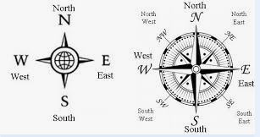
- Greek Mythology
This will across the whole term.

Geography – Spatial Sense
Within this unit we will learn:
- To describe change over time in a specific location.
- To use map skills and an eight-point compass.
- To use geographical tools and vocabulary to locate places on a map.

Art and Design
The children will use a variety of techniques to create art work around the theme of Diwali and fireworks. They will explore shape, colour and pattern.

PSHE- Think Positive
In this half term. We will be exploring topics to support with children’s self-esteem and mental strength. We will be looking at strategies we can use to have a positive mind-set and how important it is to have self-belief.


Physical Education:
This half term we will be focusing on ball skills in one session and then tag rugby in our other session. We will also be making good use of our new daily mile track.
Our PE days will be Tuesday and Wednesday.

Helping at Home:
Help at home is greatly appreciated. In addition to supporting your child with their weekly homework, below are some ideas of how you can further support your child’s achievement and learning:

- Read at least three times a week, asking your child key comprehension questions. Questions to ask your child and areas to consider can be found in many school reading books at the back of the book. A comprehension question sheet is also available upon request.
- Engage in learning times tables up to 12 x 12 off by heart.
- Read our weekly noticeboard to see what we have been working on in English and Maths. These skills can be discussed with your child to further deepen their understanding.

As you can see, we will be busy learning throughout this half term and we look forward to getting hands on with out different learning topics. We look forward to seeing the children settle into Year Three and Four and getting to know yourselves. Please do not hesitate to contact us, we are happy to help.

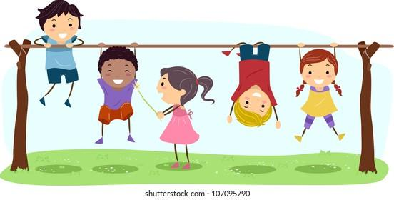
Best wishes,

Miss Dowd

