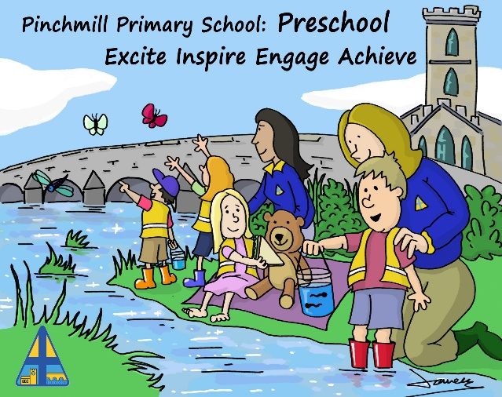
Pinchmill Primary School

Home-School Agreement

As a school
We will do our best to:
- Support your child’s wellbeing and safety by providing a safe, supportive and caring environment
- Help and encourage your child to reach their full potential
- Monitor and communicate with parents and carers regularly on your child’s progress
- Provide a broad and inclusive curriculum that caters for all children, alongside a full enrichment offer where every child has access to outdoor learning, sports and the creative arts
- Promote high standards of behaviour so we can maintain a safe environment for all children
- Offer your child opportunities to develop a sense of responsibility, form healthy social relationships and build their self-esteem
- Set regular homework that supports the delivery of the curriculum and mark it where appropriate
- Offer meaningful opportunities for parents and carers to get involved in school life and parental forums
- Communicate between home and school through accessible and clear notices, newsletters, text, email Class Dojo and the school website
- Respond to communications from parents and carers in a timely manner, following school policies
- Encourage good attendance, address any concerns with parents or carers where necessary, and provide support where possible

Signed:
Mrs Victoria Bailey
01.09.2026
Date:

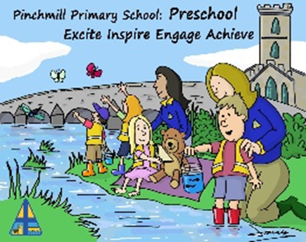
Parents/carers
I will do my best to:
- Make sure my child attends school regularly and on time, working collaboratively with the school to address any barriers to attendance. I will notify the school if my child will be absent
- Make sure my child is dressed in the correct uniform and brings their PE kit to school where necessary
- Support the school to make sure my child maintains a consistently high standard of behaviour
- Encourage my child to try their best so they can reach their full potential
- Encourage my child to read to an adult three times a week
- Communicate to the school any concerns that I have about my child that may affect their behaviour in school or ability to learn
- Make sure communication with the school is effective and respectful, and that I make every reasonable effort to address my communications to the appropriate member of staff
- Understand that I should communicate with staff during core school hours, and although they may at times respond outside of those hours, I can’t always expect that
- Encourage my child to complete their homework on time, try their best, and actively engage in the school's enrichment opportunities
- Read and follow the school’s policies
- Actively support the school’s policy of being a mobile phone-free environment
- Treat all members of the school community with care and respect, both in person and online
- Engage in parent meetings and work together with the school to achieve the best outcomes for my child
- Read all communications sent home by the school and respond where necessary

Signed:

Date:

Pupils
I will do my best to:
- Arrive at school on time every day and be ready to learn
- Try my best to do my work and ask for help if I need it
- Wear the correct school uniform and bring my PE kit to school when I need it
- Bring all the equipment I need each day
- Be friendly and caring towards other children and adults, both in person and when using online devices
- Listen to instructions from the adults at school and follow the school rules
- Do my homework and bring it back to school on time
- Look after the school equipment and be respectful of the school environment
- Behave appropriately on the way to and from school
- Follow the rules to help make sure our school is a mobile phone-free environment

Signed:

Date:

