

Pinchmill Primary School

The Old Road, Felmersham, Bedfordshire MK43 7JD

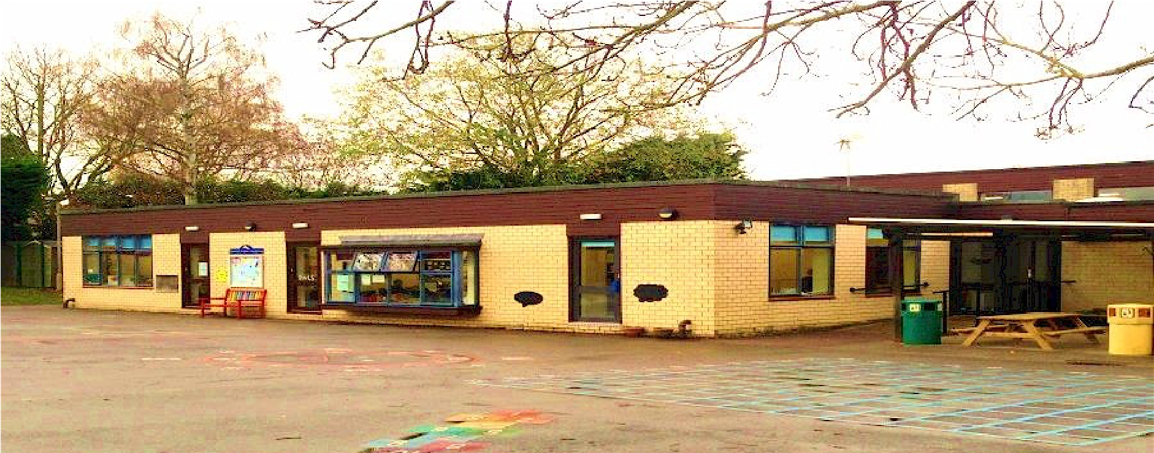

Anti-Bullying Policy

Date of Review | February 2024
Next Review Date | February 2026
Staff Responsibility | Head
Responsibility FGB/Committee | FGB
Governor Approval

Statement of Intent
We are committed to providing a caring, friendly and safe environment for all of our pupils so they can learn in a relaxed and secure atmosphere. Bullying of any kind is unacceptable at our school. If bullying does occur, all pupils should be able to tell and know that incidents will be dealt with promptly and effectively. We are a TELLING school. This means that anyone who knows that bullying is happening is expected to tell the staff.

What Is Bullying?
Bullying is a repeated, intentional behaviour where a child uses power to harm or intimidate peers, and it can have lasting emotional and social effects.

Bullying can be:
• | Emotional | being unfriendly, excluding, tormenting (e.g. hiding books, threatening gestures)
• | Physical | pushing, kicking, hitting, punching or any use of violence
• | Racist | racial taunts, graffiti, gestures
• | Sexual | unwanted physical contact or sexually abusive comments
• | Homophobic | because of, or focussing on the issue of sexuality
• | Verbal | name-calling, sarcasm, spreading rumours, teasing
• | Cyber | All areas of internet, such as email & internet chat room misuse  Mobile threats by text messaging & calls  Misuse of associated technology , i.e. camera &video facilities

Why is it Important to Respond to Bullying?
Bullying hurts. No one deserves to be a victim of bullying. Everybody has the right to be treated with respect. Pupils who are bullying need to learn different ways of behaving.

Schools have a responsibility to respond promptly and effectively to issues of bullying.

Objectives of this Policy
- All governors, teaching and non-teaching staff, pupils and parents should have an understanding of what bullying is.
- All governors, teaching and non-teaching staff should know what the school policy is on bullying, and follow it when bullying is reported.
- All pupils and parents should know what the school policy is on bullying, and what they should do if bullying arises.
- As a school we take bullying seriously. Pupils and parents should be assured that they will be supported when bullying is reported.
- Bullying will not be tolerated.

Signs and Symptoms
A child may indicate by signs or behaviour that he or she is being bullied. Adults should be aware of these possible signs and that they should investigate if a child:
- is frightened of walking to or from school
- doesn't want to go on the school/public bus
- begs to be driven to school
- changes their usual routine
- is unwilling to go to school (school phobic)
- begins to truant
- becomes withdrawn anxious, or lacking in confidence
- starts stammering
- attempts or threatens suicide or runs away
- cries themselves to sleep at night or has nightmares
- feels ill in the morning
- begins to do poorly in school work
- comes home with clothes torn or books damaged
- has possessions which are damaged or "go missing"
- asks for money or starts stealing money (to pay bully)
- has dinner or other monies continually "lost"
- has unexplained cuts or bruises
- comes home starving (money/lunch has been stolen)
- becomes aggressive, disruptive or unreasonable
- is bullying other children or siblings
- stops eating
- is frightened to say what's wrong
- gives improbable excuses for any of the above
- is afraid to use the internet or mobile phone
- is nervous & jumpy when a cyber message is received

These signs and behaviours could indicate other problems, but bullying should be considered a possibility and should be investigated

Procedures
- Report bullying incidents to staff
- In cases of serious bullying, the incidents will be recorded by staff
- In serious cases parents should be informed and will be asked to come into a meeting to discuss the problem
- If necessary and appropriate, police will be consulted
- The bullying behaviour or threats of bullying must be investigated and the bullying stopped quickly 6. An attempt will be made to help the bully (bullies) change their behaviour

Outcomes

- The bully (bullies) may be asked to genuinely apologise. Other consequences may take place.
- In serious cases, suspension or even exclusion will be considered
- If possible, the pupils will be reconciled
- After the incident / incidents have been investigated and dealt with, each case will be monitored to ensure repeated bullying does not take place.

Prevention
We will use KIDSCAPE methods for helping children to prevent bullying. As and when appropriate, these may include:
- writing a set of school rules
- signing a behaviour contract
- writing stories or poems or drawing pictures about bullying
- reading stories about bullying or having them read to a class or assembly
- making up role-plays (or using KIDSCAPE role-plays)
- having discussions about bullying and why it matters

HELP ORGANISATIONS:
Advisory Centre for Education (ACE) | 0808 800 5793
Children's Legal Centre | 0845 345 4345
KIDSCAPE Parents Helpline (Mon-Fri, 10-4) | 0845 1 205 204
Parentline Plus | 0808 800 2222
Youth Access | 020 8772 9900
Bullying Online | www.bullying.co.uk

Visit the Kidscape website www.kidscape.org.uk for further support, links and advice, this policy has been written considering the Kidscape advice and procedures.

Monitoring and Reviewed

The policy will be monitored and reviewed by the Head Teacher and will be endorsed by the Governing Body.

