Pinchmill Primary School



Primary Relationships and Health Education Policy

Approved by: | Mrs V Bailey | Date Sept 26
Sourced: | The Key
Last reviewed on: | Sept 26
Next review due by: | Sept 27

Statement of intent
At Pinchmill Primary School, we will provide age-appropriate relationships and health education (RHE) to all pupils as part of the school’s statutory curriculum. Our school aims to assure parents and pupils that all aspects of RHE will be delivered in a safe space, allowing time and compassion for questions at a level that every pupil understands. Sensitive topics relating to RHE will be delivered in a sensitive manner as part of a whole-school approach where parents and teachers work in partnership.
RHE is compulsory in all primary schools in England. The key topics applicable for all key stages have been carefully planned in consultation with responses from parents, young people, schools and experts. Parents are given the opportunity to discuss this policy at any time and staff will be provided with accurate training and further resources to deliver lessons to pupils.
We understand that pupils must be provided with an education that prepares them for the opportunities, responsibilities and experiences of adult life. A key part of this relates to relationships education, which is required to be delivered to every primary-aged pupil. Primary schools also have the option to decide whether pupils are taught sex education.
Relationships education focusses on giving pupils the knowledge they need to make informed decisions about their wellbeing, health and relationships, and ensures can talk to a trusted adult if there is anything worrying them. Health education focusses on equipping pupils with the knowledge they need to make informed decisions about their own health and ensures they receive factual information about the changes they will experience emotionally and physically during puberty.
We understand our responsibility to deliver a high-quality, age-appropriate and evidence-based RHE curriculum for all our pupils. This policy sets out the framework for our relationships and health curriculum, providing clarity on how it is informed, organised and delivered.

Legal framework
This policy has due regard to all relevant legislation and statutory guidance including, but not limited to, the following:
- Education Act 1996
- Section 80A and section 403 of the Education Act 2002
- Equality Act 2010
- Children and Social Work Act 2017
- The Relationships Education, Relationships and Sex Education and Health Education (England) Regulations 2019
- DfE (2025) ‘Science programmes of study: key stages 1 and 2’
- DfE (2025) ‘Relationships Education, Relationships and Sex Education (RSE) and Health Education’
- DfE (2021) ‘Teaching about relationships, sex and health’
- DfE (2052) ‘Keeping children safe in education 2025’

Roles and responsibilities
The governing board will be responsible for:
- Playing an active role in monitoring, developing and reviewing the policy and its implementation in school.
- Appointing a link governor for RHE who supports the school and monitors any aspects of RHE included within the SIP.
- Ensuring all pupils make progress in achieving the expected educational outcomes.
- Ensuring the curriculum is well led, effectively managed and well planned.
- Evaluating the quality of provision through regular and effective self-evaluation.
- Ensuring teaching is delivered in ways that are accessible to all pupils with SEND.
- Providing clear information for parents on subject content and their rights to request that their children are withdrawn from sex education teaching.
- Making sure the subjects are resourced, staffed and timetabled in a way that ensures the school can fulfil its legal obligations.
- Creating and keeping up to date a separate written statement of this policy and ensuring the statement is published on the school’s website and provided free of charge to anyone who requests it.
- Ensuring that all staff receive ongoing training on issues relating to PSHE and RHE and how to deliver lessons on such issues.
- Ensuring that all staff are up to date with policy changes, and familiar with school policy and guidance relating to RHE.
The Head Teacher will be responsible for:
- The overall implementation of this policy.
- Ensuring adequate time on school timetable to deliver RHE as a statutory curriculum subject.
- Providing support to staff members who feel uncomfortable or ill-equipped to deal with the delivery of RHE to pupils; for example, if staff do not feel that their training has been adequate or that aspects of the curriculum conflict with their religious beliefs.
- Ensuring that parents are fully informed of this policy and the RHE resources are available to parents beforehand.
- Organising alternative education for pupils, where necessary, that is appropriate and purposeful.
- Reporting to the governing board on the effectiveness of this policy.
- Reviewing this policy on an annual basis.
The RHE subject leader will be responsible for:
- Overseeing the delivery of the subjects.
- Ensuring that staff values and attitudes will not prevent them from providing a balanced RHE in school.
- Providing the agreed vocabulary to be used during the lessons to ensure a consistent approach.
- Ensuring the subjects are age-appropriate and high-quality and up to date.
- Ensuring teachers are provided with adequate resources to support teaching of the subjects.
- Ensuring the school meets its statutory requirements in relation to the relationships, and health curriculum.
- Ensuring the relationships and health curriculum is inclusive and accessible for all pupils.
- Working with other subject leaders to ensure the relationships and health curriculum complements, but does not duplicate, the content covered in the national curriculum.
- Liaising and working in partnership with parents and carers to support further conversations at home and to share the resources ahead of teaching upon request.
- Monitoring and evaluating the effectiveness of the subjects and providing reports to the headteacher.
The SENCO will be responsible for:
- Advising teaching staff how best to identify and support pupils’ individual needs.
- Advising staff on the use of TAs in order to meet pupils’ individual needs.
- Ensuring that the needs of vulnerable pupils are taken into consideration in designing and teaching these subjects.
All teachers will be responsible for:
- Delivering a high-quality and age-appropriate relationships and health curriculum in line with statutory requirements.
- Using a variety of teaching methods and resources to provide an engaging curriculum that meets the needs of all pupils.
- Ensuring they do not express personal views or beliefs when delivering the programme.
- Modelling positive attitudes to relationships and health.
- Responding to any safeguarding concerns in line with the Child Protection and Safeguarding Policy.
- Acting in accordance with planning, monitoring and assessment requirements for the subjects.
- Liaising with the SENCO to identify and respond to individual needs of pupils with SEND.
- Working with the RHE subject leader to evaluate the quality of provision.
Parents will be responsible for:
- Supporting their children through their personal development and the emotional and physical aspects of growing up.
- Ensuring that they are aware of curriculum content, organisation and delivery.
- Fostering an open home environment where pupils can engage, discuss and continue to learn about topics that have been taught in school.
- Liaising with the school to seek additional support if needed.

Organisation of the curriculum
The school understands that it is required to deliver statutory relationships education and health education, and that it has the freedom to determine how this will be taught in the context of a broad and balanced curriculum.
The school will organise the teaching of RHE:
- As part of the PSHE curriculum
For the purpose of this policy:
- “Relationships education” is defined as teaching pupils about healthy, respectful relationships, focussing on family and friendships, in all contexts, including online.
- “Health education” is defined as teaching pupils about physical health and mental wellbeing, focussing on recognising the link between the two and being able to make healthy lifestyle choices.
The relationships and health curriculum takes into account the views of teachers, pupils and parents. The school has organised a curriculum that is in line with the statutory requirement and is appropriate for the age and developmental stages of pupils within each year group. When organising the curriculum, the religious backgrounds of all pupils will be considered, so that the topics that are covered are taught appropriately.
The school is dedicated to ensuring the RHE curriculum meets the needs of the whole community; therefore, the curriculum is informed by issues in both the school, and the wider community, to ensure it is tailored to pupils’ needs.
The school will teach pupils the knowledge they need to recognise and report abuse, including emotional, physical and sexual abuse. Teaching will focus on ensuring pupils understand boundaries and privacy with peers, families and others, in all contexts, including online.
The school will consult with parents, pupils and staff in the following ways:
- Meetings
- Newsletters and letters
Any parent, teacher or pupil wishing to provide feedback about the curriculum will be able to do so at any time during the academic year by:
- Organising a meeting with the Head Teacher or RHE lead

Consultation with parents
The school understands the important role parents play in enhancing their children’s understanding of relationships and health and how important parents’ views are in shaping the curriculum.
The school will consult closely with parents when reviewing the content of the school’s RHE curriculum and will give them regular opportunities to voice their opinions. The school will use the views of parents to inform decisions made about the curriculum content and delivery; however, parents will not be granted a ‘veto’ on curriculum content, and all final decisions will be made by school. The school will permit parents access to all curriculum materials and the school will not enter into contracts with outside providers that seek to prevent parents from seeing materials.
The school will be mindful of the personal circumstances of all pupils to ensure there is no stigmatisation of based on home circumstances, support networks or family needs.
Parents will be provided with the following information:
- The content of the relationships and health curriculum
- The delivery of the relationships and health curriculum, including what is taught in each year group
- The legalities surrounding withdrawing their child from the subjects
- The resources that will be used to support the curriculum

Relationships education overview

Families and people who care for me
By the end of primary school, pupils will know:
- That families are important for them growing up because they can give love, security and stability.
- The characteristics of healthy family life, commitment to each other, including in times of difficulty, protection and care for children and other family members, the importance of spending time together and sharing each other’s lives.
- That others’ families, either in school or in the wider world, sometimes look different from their family, but that they should respect those differences and know that other children’s families are also characterised by love and care.
- That stable, caring relationships, which may be of different types, are at the heart of happy families, and are important for children’s security as they grow up.
- That marriage represents a formal and legally recognised commitment of two people to each other which is intended to be lifelong.
- How to recognise if family relationships are making them feel unhappy or unsafe, and how to seek help or advice from others if needed.

Caring friendships
By the end of primary school, pupils will know:
- How important friendships are in making us feel happy and secure, and how people choose and make friends.
- The characteristics of friendships, including mutual respect, truthfulness, trustworthiness, loyalty, kindness, generosity, trust, sharing interests and experiences, and support with problems and difficulties.
- That healthy friendships are positive and welcoming towards others, and do not make others feel lonely or excluded.
- That most friendships have ups and downs, but that these can often be worked through so that the friendship is repaired or even strengthened, and that resorting to violence is never right.
- How to recognise who to trust and who not to trust.
- How to judge when a friendship is making them feel unhappy or uncomfortable.
- How to manage conflict.
- How to manage different situations and how to seek help from others if needed.

Respectful relationships
By the end of primary school, pupils will know:
- The importance of respecting others – even when they are very different from them (for example, physically, character, personality or background), or make different choices, or have different preferences or beliefs.
- Which practical steps they can take in a range of different contexts to improve or support respectful relationships.
- The conventions of courtesy and manners.
- The importance of self-respect and how this links to their own happiness.
- That in school and wider society they can expect to be treated with respect by others, and that in turn they should show due respect to others, including those in positions of authority.
- About the different types of bullying (including cyberbullying), the impact of bullying, responsibilities of bystanders and to report bullying to an adult, and how to seek help.
- What a stereotype is, and how they can be unfair, negative or destructive.
- The importance of permission-seeking and giving in relationships with friends, peers and adults.

Online relationships
By the end of primary school, pupils will know:
- That people sometimes behave differently online, including pretending to be someone they are not.
- That the same principles apply to online relationships as to face-to-face relationships, including the importance of respect for others online, even when we are anonymous.
- The rules and principles for keeping safe online.
- How to recognise harmful content and contact online, and how to report these.
- How to critically consider their online friendships and sources of information.
- The risks associated with people they have never met.
- How information and data is shared and used online.

Being safe
By the end of primary school, pupils will know:
- What sorts of boundaries are appropriate in friendships with peers and others – including in a digital context.
- About the concept of privacy and the implications of it for both children and adults.
- That it is not always right to keep secrets if they relate to being safe.
- That each person’s body belongs to them, and the differences between appropriate and inappropriate or unsafe physical, and other, contact.
- How to respond safely and appropriately to adults they may encounter, including online, who they do not know.
- How to recognise and report feelings of being unsafe or feeling bad about any adult.
- How to ask for advice or help for themselves and others, and to keep trying until they are heard.
- How to report concerns or abuse, and the vocabulary and confidence needed to do so.
- Where to seek advice, for example, from their family, their school and other sources.

Relationships education and health education for KS1, LKS2 and UKS2
The school is free to determine, within the statutory curriculum content outlined in the ‘Relationships education overview’ section, what pupils are taught during each year group.
The school always considers the age and development of pupils when deciding what will be taught in each year group. The school implements a progressive curriculum, in which topics are built upon prior knowledge taught in previous years as pupils progress through school, with a view to providing a smooth transition to secondary school.
The focus of health education at primary level is teaching the characteristics of good physical health and mental wellbeing.
We use Twinkl to support our teaching of PSHE in the school and the overview of each unit and what is taught in each year group is listed below.

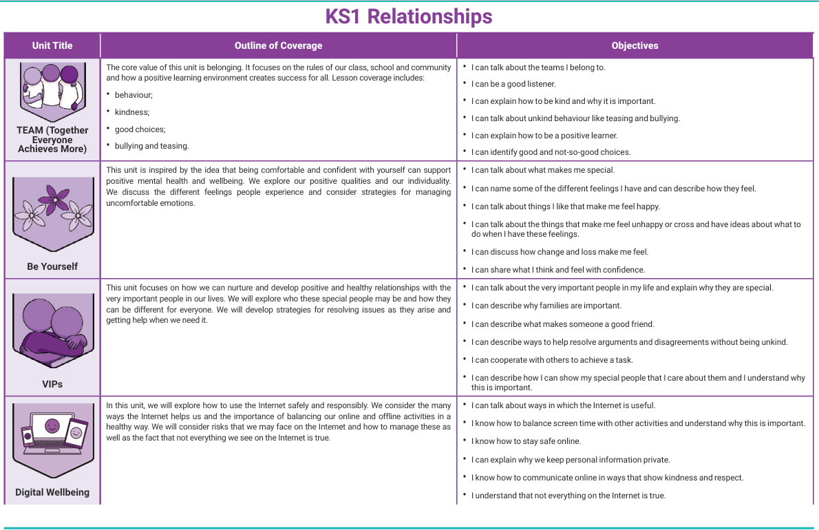

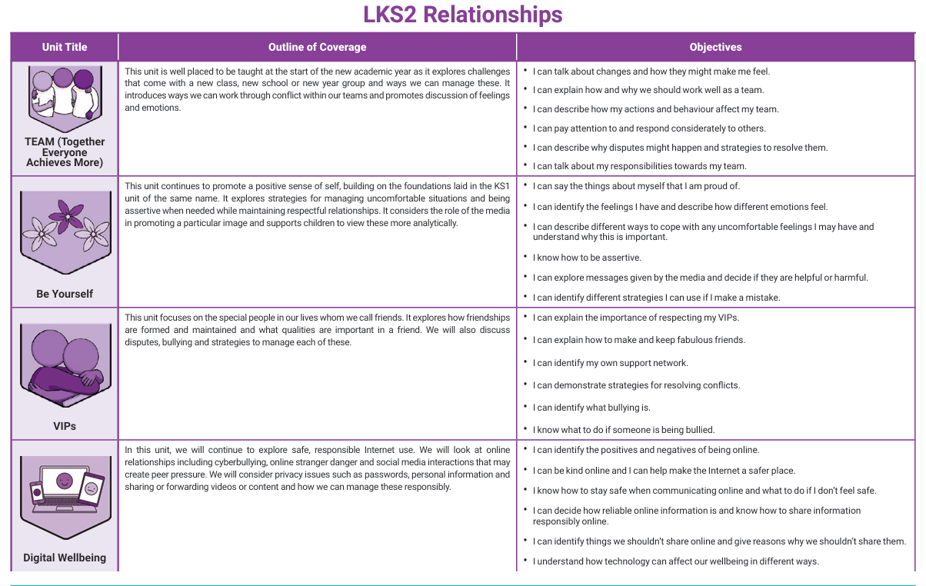
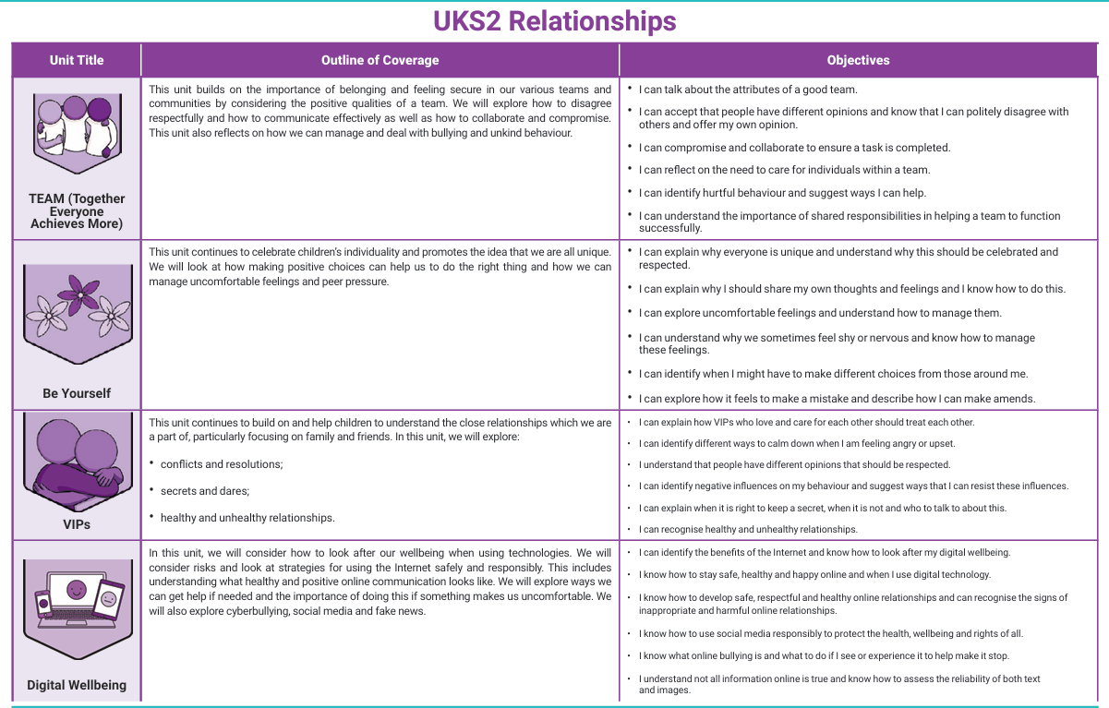

We do not teach anything related to sex on the overview above. This has all been removed from the planning.

Mental wellbeing
By the end of primary school pupils will know:
- That mental wellbeing is a normal part of daily life, in the same way as physical health.
- That there is a normal range of emotions, e.g. happiness, sadness, anger, fear, surprise and nervousness.
- The scale of emotions that humans experience in response to different experiences and situations.
- How to recognise and talk about their emotions, including having a varied vocabulary of words to use when talking about their own and others’ feelings.
- How to judge whether what they are feeling, and how they are behaving, is appropriate and proportionate.
- The benefits of physical exercise, time outdoors, community participation, and voluntary and service-based activity on mental wellbeing and happiness.
- Simple self-care techniques, including the importance of rest, time spent with friends and family, and the benefits of hobbies and interests.
- How isolation and loneliness can affect children, and that it is very important they seek support and discuss their feelings with an adult.
- That bullying, including cyberbullying, has a negative and often lasting impact on mental wellbeing.
- Where and how to seek support, including recognising the triggers for seeking support, extending to who in school they should speak to if they are worried about themselves or others.
- That it is common to experience mental ill health and, for the many people who do, the problems can be resolved if the right support is made available, especially if accessed early enough.

Internet safety and harms
By the end of primary school, pupils will know:
- That for most people, the internet is an integral part of life and has many benefits.
- About the benefits of rationing time spent online.
- The risks of excessive time spent on electronic devices.
- The impact of positive and negative content online on their own and others’ mental and physical wellbeing.
- How to consider the effect of their online actions on others.
- How to recognise and display respectful behaviour online.
- The importance of keeping personal information private.
- Why some social media, some computer games and online gaming are age restricted.
- That the internet can also be a negative place where online abuse, trolling, bullying and harassment can take place, which can have a negative impact on mental health.
- How to be a discerning consumer of information online, including understanding that information, inclusive of that from search engines, is ranked, selected and targeted.
- Where and how to report concerns and get support with issues online.

Physical health and fitness
By the end of primary school, pupils will know:
- The characteristics and mental and physical benefits of an active lifestyle.
- The importance of building regular exercise into daily and weekly routines and how to achieve this, for example by walking or cycling to school, a daily active mile, or other forms of regular, vigorous exercise.
- The risks associated with an inactive lifestyle, including obesity.
- How and when to seek support, including which adults to speak to in school, if they are worried about their health.

Healthy eating
By the end of primary school, pupils will know:
- What constitutes a healthy diet, including an understanding of calories and other nutritional content.
- The principles of planning and preparing a range of healthy meals.
- The characteristics of a poor diet and risks associated with unhealthy eating, including obesity, and other behaviours, e.g. the impact of alcohol on health.

Drugs, alcohol and tobacco
By the end of primary school, pupils will know the facts about legal and illegal harmful substances and associated risks, including smoking, alcohol use and drug-taking.

Health and prevention
By the end of primary school, pupils will know:
- How to recognise early signs of physical illness, such as weight loss or unexplained changes to the body.
- About safe and unsafe exposure to the sun, and how to reduce the risk of sun damage, including skin cancer.
- The importance of sufficient good-quality sleep for good health, and that a lack of sleep can affect weight, mood and ability to learn.
- About dental health and the benefits of good oral hygiene and dental flossing, including regular check-ups at the dentist.
- About personal hygiene and germs, including bacteria and viruses, how they are spread and treated, and the importance of hand washing.
- The facts and science relating to immunisation and vaccination.

Basic first aid
By the end of primary school, pupils will know:
- How to make a clear and efficient call to emergency services if necessary.
- Concepts of basic first aid, for example dealing with common injuries, including head injuries.

Changing adolescent body
By the end of primary school, pupils will know:
- Key facts about puberty and the changing adolescent body, particularly from age 9 through to age 11, including physical and emotional changes.
- About menstrual wellbeing and key facts relating to the menstrual cycle.

Sex education
All pupils must be taught the aspects of sex education outlined in the primary science curriculum; however, the school is free to determine whether pupils should be taught sex education beyond what is required of the national curriculum, with our approach being that:
At Pinchmill Primary School we do not teach pupils sex education beyond what is required of the science curriculum.

Delivery of the curriculum
The RHE curriculum will be delivered:
- As part of the PSHE curriculum
The school will ensure that keeping children safe and preventative education remain at the heart of PSHE and RHE teaching.
Through effective organisation and delivery of the subject, the school will ensure that:
- Core knowledge is sectioned into units of manageable size.
- The required content is communicated to pupils clearly, in a carefully sequenced way, within a planned scheme of work.
- Teaching includes sufficient and well-chosen opportunities and contexts for pupils to embed new knowledge so that it can be used confidently in real-life situations.
The curriculum will be delivered proactively, such that it addresses issues in a timely way in line with current evidence on children’s physical, emotional development.
Teaching of the curriculum will reflect requirements set out in law, particularly the Equality Act 2010, so that pupils understand what the law does and does not allow and the wider legal implications of the decisions they make.
The school will ensure that all teaching and materials are appropriate for the ages of the pupils, their religious backgrounds, developmental stages and any additional needs, such as SEND. All learning resources will be selected with sensitivity, e.g. diagrams, videos, books and games, and inappropriate images, videos etc., will not be used. Any resources or materials used will be formally assessed by the RHE subject leader before use to ensure they are appropriate for the age and maturity of pupils and sensitive to their needs.
The school will ensure that it meets the DfE’s technology filtering and monitoring standards to ensure that pupils are unable to access inappropriate materials when using the internet to assist with their learning, as well as ensuring all members of the school community adhere to the provisions outlined in the school’s Online Safety Policy.
Lesson plans and teaching will provide appropriate challenge for pupils and be differentiated for pupils’ needs. Teachers will:
- Establish what is appropriate for 1-2-1 and whole-class settings.
- Alter their teaching according to pupils’ age, stage, understanding and background.
- Listen and answer questions sensitively, honestly and appropriately.
- Encourage pupils to ask questions and engage in discussion.
- Ensure teaching focuses on boys and girls equally.
- Plan activities to matching pupils’ differing learning styles.
Whilst there are no formal examinations for the relationships and health curriculum, teachers will conduct ongoing formative assessment of pupil’s knowledge and awareness. Any concerns regarding a pupils’ understanding will be raised with their parents.

Opportunities to teach safeguarding
Further to the prescribed curriculum for RHE, teaching will focus on safeguarding and preventative education
The school will ensure that, as part of relationships education, pupils are taught about how to keep themselves and others safe, including online.
Education will be tailored to the specific needs and vulnerabilities of individual pupils whilst taking account of pupils who may be victims of abuse and pupils who have SEND.
Preventative education will be adopted as a whole-school approach that prepares pupils for life in modern Britain and creates a zero-tolerance culture for sexism, misogyny/misandry, homophobia, biphobia and sexual violence or harassment.
The school is aware that pupils may raise topics such as self-harm and suicide. When discussing these topics in lessons, teachers will be aware of the risks of encouraging these behaviours and will avoid any resources or material that appear as instructive rather than preventative,
The school will have a clear set of values and standards which will be underpinned by the Behaviour Policy and pastoral support system, as well as by a planned programme of evidence based RHE curriculum.

The teaching of safeguarding and preventative education will be fully inclusive and developed to be age and stage of development appropriate.

Curriculum organisation
Pupils will receive their entitlement for learning PSHE through a spiral curriculum which demonstrates progression. The RHE programme is delivered through a variety of opportunities including:
- Designated PSHE time as part of a spiral curriculum
- Circle time
- School ethos
- Cross curricular links
- Assemblies
- Residential trips

Terminology
In recognition of the fact that the use of code names for body parts can facilitate the normalisation of child sexual abuse, teaching staff will use and teach pupils the anatomically correct names for body parts.

Dealing with difficult questions
The school will support teaching staff to feel comfortable to answer questions from pupils, by providing regular CPD training where appropriate, including sessions on confidentiality, setting ground rules, handling controversial issues, responding to ‘awkward’ questions and an introduction to the rationale of why teaching RHE is so important. The school will encourage teaching staff to refer questions they feel ill-equipped to answer to the RHE subject leader for advice or support in responding to the question.
Teachers will stop full class discussions where pupils begin to reveal personal, confidential information related to sensitive issues. If teachers feel concerned about anything shared by a pupil, they will follow the appropriate response as laid out in the Child Protection and Safeguarding Policy.
The programme will be designed to incorporate all pupils, and activities will be planned to ensure all are actively involved.
Teachers will focus heavily on the importance of healthy relationships, though sensitivity will always be given as to not stigmatise pupils based on their home circumstances.

Assessment
Whilst there are no formal examinations for the relationships and health curriculum, the school will undertake informal assessments to determine pupil progress – these include the following:
- Group tasks
- Class discussions

Working with external experts
The school may invite guest speakers into school to talk on issues related to RHE, e.g. an expert or experienced health professional who can challenge pupil’s perceptions. A teacher will be present throughout these lessons.
Visitors will be given a copy of this policy and expected to comply with the guidelines outlined within it. All resources used by guest speakers will be available to parents to view prior to lesson delivery.

Before delivering the session, the school will:
- Ensure the lesson the external expert has planned fits with the school’s planned curriculum and this policy.
- Ensure the expert’s credentials are checked before they can participate in delivery of the curriculum, in line with the Visitor Policy.
- Discuss the details of the expert’s lesson plan and ensure that the content is age-appropriate and accessible for the pupils.
- Ask to see the materials the expert intends to use, as well as a copy of the lesson plan, to ensure it meets all pupils’ needs, including those with SEND.
- Agree with the expert the procedures for confidentiality, ensuring that the expert understands how safeguarding reports should be dealt with in line with the Child Protection and Safeguarding Policy.

Equality and accessibility
The school understands its responsibilities in relation to the Equality Act 2010; specifically, that it must not unlawfully discriminate against any pupil based on their protected characteristics.
The protected characteristics are:
- Age
- Sex or sexual orientation
- Race
- Disability
- Religion or belief
- Gender reassignment
- Pregnancy or maternity
- Marriage or civil partnership
The school is committed to making reasonable adjustments wherever possible to promote accessibility and inclusivity of the curriculum. The school will ensure that RHE programme is inclusive, and caters to the needs, of pupils with SEND or other support needs, such as those with SEMH needs.
Teachers will understand that they may need to adapt their planning of work and teaching methods in order to appropriately deliver the programme to pupils with SEND or other support needs.
Provisions under the Equality Act 2010 allow our school to take positive action, where it can be evidenced to be proportionate, to respond to disadvantages affecting a group because of a protected characteristic. For example, we could consider taking positive action to support girls if there was evidence that they were being disproportionately subjected to sexual violence of sexual harassment.
When deciding whether support is necessary to support pupils with a particular protected characteristic, we will consider our pupils’ needs, including the gender and age range of our pupils.
In order to foster healthy and respectful peer-to-peer communication and behaviour between all pupils, the school will implement a robust Behaviour Policy, as well as a Child Protection and Safeguarding Policy, which sets out expectations of pupils.
The school understands that RHE may include topics which are triggers for teaching staff, and could relate to historic, recent, or current trauma. If this is the case, the school encourages staff to approach their line manager or the wellbeing lead to discuss this.

Curriculum links
The school seeks opportunities to draw links between RHE and other curriculum subjects wherever possible to enhance pupils’ learning. RHE will be linked to the following subjects in particular:
- Science – pupils learn about the main external parts of the body and changes to the body as it grows from birth to old age, including puberty.
- Computing and ICT – pupils learn about e-safety, including how to use technology safely, responsibly, respectfully and securely, how to keep personal information private and how to access help and support.
- PE – pupils explore various physical activities, are physically active for sustained periods of time, engage in competitive sport and understand how exercise can lead to healthier lifestyles.
- PSHE – pupils learn about respect and difference, values and characteristics of individuals.

Withdrawing from certain subjects
RHE are statutory at primary and parents do not have the right to withdraw their child from the subjects.

Behaviour
The school aims to foster a culture based on mutual respect and understanding for one another, and as such, has a zero-tolerance approach to bullying. Any bullying incidents caused as a result of the RHE programme, such as those relating to sexual orientation, will be dealt with as seriously as other bullying incidents within the school. Any occurrence of these incidents will be reported to a member of school staff, who will then discipline the pupil once they are on school premises. These incidents will be dealt with following the processes in our Behaviour Policy and Anti-bullying Policy.
The headteacher will decide whether it is appropriate to notify the police or an anti-social behaviour coordinator in their LA of the action taken against a pupil.

Staff training
All staff members at the school will undergo training on a yearly basis to ensure they are up to date with the RHE programme and associated issues.
Training of staff will also be scheduled around any updated guidance on the programme and any new developments, such as ‘sexting,’ which may need to be addressed in relation to the programme.

Confidentiality
The school will aim to provide a safe and supportive school community where pupils feel comfortable seeking help and guidance on anything that may be concerning them about life either at school or at home. Training around confidentiality will be provided to all teachers.
The school is aware that confidentiality within the classroom is a critical component of RHE, and teachers will be expected to respect the confidentiality of their pupils as far as is possible and appropriate.
It may be the case that discussion around what is acceptable and not acceptable in relationships may lead to the disclosure of a child protection issue. If this is the case, the school’s Child Protection and Safeguarding Policy will be followed.
Pupils will be informed prior to delivery of RHE lessons about confidentiality, though will be informed that appropriate action will be taken if staff feel that a child is at risk of harm. Staff who breach the right to a child’s privacy by disclosing or sharing confidential information with no reason to do so may face disciplinary procedures.

Quality of education
The RHE subject leader is responsible for monitoring the quality of teaching and learning for the subjects. They will conduct subject assessments on a termly basis, which will include a mixture of the following:
- Self-evaluations
- Lesson observations
- Learning walks
- Pupil voice
The RHE subject leader will create annual subject reports for the headteacher and governing board to report on the quality of the subjects. They will also work regularly and consistently with the headteacher and RHE link governor, e.g. through termly review meetings, to evaluate the effectiveness of the subjects and implement any changes.

Monitoring and review
The governing board is responsible for approving this policy.
This policy will be reviewed on an annual basis by the RHE subject leader and headteacher. The next scheduled review date for this policy is 1.09.26. This policy will also be reviewed in light of any changes to statutory guidance; feedback from parents, staff or pupils; and issues in the school or local area that may need addressing.
Any changes made to this policy will be communicated to all staff, parents and, where necessary, pupils.

