

Pinchmill Primary School

The Old Road, Felmersham, Bedfordshire MK43 7JD

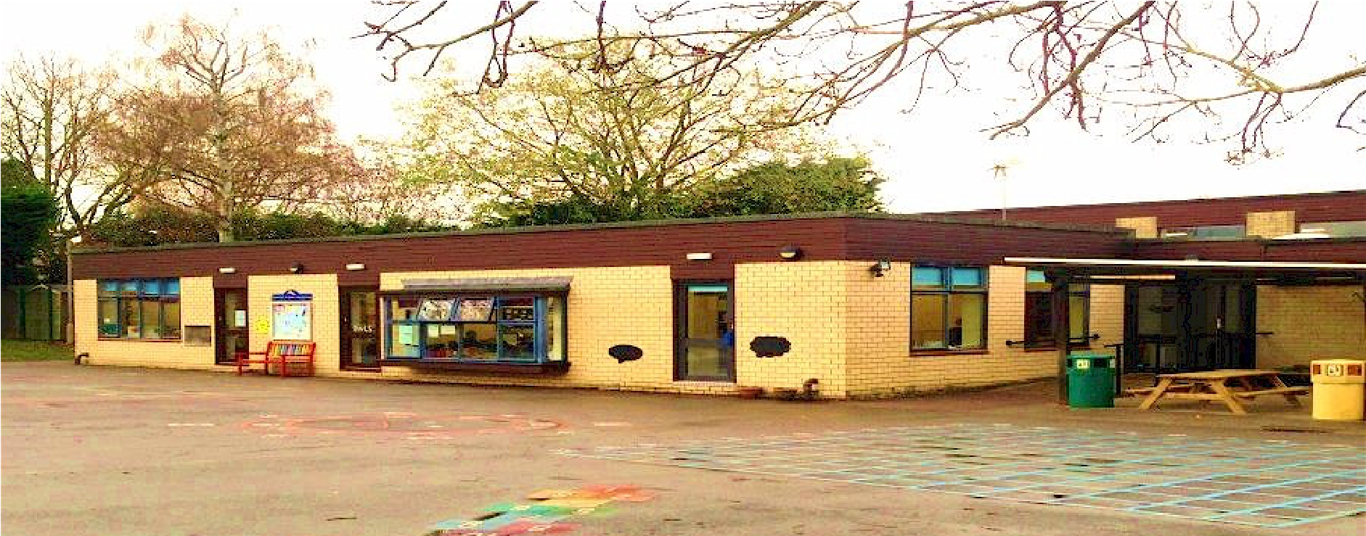

Remote Education Provision: Information for Parents

Date of Review | As and when required
Next Review Date | N/A
Staff Responsibility | Head
Responsibility FGB/Committee | FGB
Governor Approval

This information is intended to provide clarity and transparency to pupils and parents or carers about what to expect from remote education where national or local restrictions require entire cohorts (or bubbles) to remain at home.

For details of what to expect where individual pupils are self-isolating, please see the final section of this page.

The remote curriculum: what is taught to pupils at home

A pupil’s first day or two of being educated remotely might look different from our standard approach, while we take all necessary actions to prepare for a longer period of remote teaching.

What should my child expect from immediate remote education in the first day or two of pupils being sent home? We will use our Website to post a timetable for each class to follow. This will give information and resources on what your child should be doing throughout each day over the week. You will also be emailed links through our school email communication system which will give you times for the daily online live teaching sessions

Following the first few days of remote education, will my child be taught broadly the same curriculum as they would if they were in school?
We teach the same curriculum remotely as we do in school wherever possible and appropriate. However, we have needed to make some adaptations in some subjects. For example, where we would teach Art and DT in school and would have the appropriate tools and resources we will adapt to use other resources that you are likely to have around the house. We will also be adapting PE because of the children being on their own at home.
We will either provide resources to support the children’s learning or adapt their learning and activities so that they are appropriate for the home environment.
The emphasis from the Government for Reception children is on reading and phonics, so the teaching sessions will focus on these areas.

Remote teaching and study time each day

How long can I expect work set by the school to take my child each day?
We expect that remote education (including remote teaching and independent work) will take pupils broadly the following number of hours each day:

Reception | 2 hours
Key Stage 1 | 4 hours – there are minimum expectations for remote provision.
Key Stage 2 | 5 hours

Accessing remote education

How will my child access any online remote education you are providing?
All information and instructions, including links to videos and live teaching sessions will be provided to you, wither through the website for teaching resources, videos and tasks, or through email with links for the live teaching sessions.

If my child does not have digital or online access at home, how will you support them to access remote education? We recognise that some pupils may not have suitable online access at home. We take the following approaches to support those pupils to access remote education:

If you do not have access to laptops or tablets for your child we may be able to provide these for your child. If you contact Vanessa Coleman on vcoleman@pinchmillprimary.co.uk, or telephone the school office, then we will do our best to make arrangements for loans of laptops during the time we are learning remotely.
If you need to borrow devices that enable an internet connection (for example, routers or dongles), please also contact Vanessa Coleman as above.
If you require any printed materials then please notify us either through you child’s class teacher or via the details above and we will be happy to make arrangements for you to either collect them from the office or to have them delivered directly to you.

How will my child be taught remotely?
We use a combination of the following approaches to teach pupils remotely:
- live teaching (online lessons)
- recorded teaching (e.g. Oak National Academy lessons, video/audio recordings made by teachers)
- printed paper packs produced by teachers (e.g. workbooks, worksheets)
- textbooks and reading books pupils have at home
- commercially available websites supporting the teaching of specific subjects or areas, including video clips or sequences
- long-term project work and/or internet research activities
- provision of online reading programme: Scholastic Reading-Pro for Y2 to 6

Engagement and feedback

What are your expectations for my child’s engagement and the support that we as parents and carers should provide at home?
The children in Reception will have two live teaching sessions per day, one including a story time, this session will also be open to Nursery children.
We are expecting all children to attend all sessions, and will provide additional support for those children that need support or help with their learning outside of these sessions as requested by parents or the children. Teachers will also offer additional sessions for small groups or individually for children identified as needing extra time or input.
We would ask that parents support us in teaching your child, by encouraging a commitment to our expectations above and help with the setting of routines to support your child’s education, we would also ask that you make sure that your child has an appropriate place to work and have the resources they need at hand so that they can focus on the tasks and teaching as soon as lessons begin.
We would also like you to support your children with regular reading, particularly the children in our Reception Class.

How will you check whether my child is engaging with their work and how will I be informed if there are concerns? We will be taking a daily register of the live teaching sessions throughout the day and will be monitoring engagement with these and the set tasks following the teaching.
If your child is showing a lack of engagement with these sessions you will receive an email from the class teacher or a telephone call from the Head Teacher to explore the reasons for this and to try to find a suitable solution for this.

How will you assess my child’s work and progress?
Feedback can take many forms and may not always mean extensive written comments for individual children. For example, whole-class feedback or quizzes marked automatically via digital platforms are also valid and effective methods, amongst many others. Our approach to feeding back on pupil work is as follows:

To assess and feedback we will use a combination of verbal feedback which will be immediate or in the next session following an evaluation of the children’s work, and some written feedback either online using the media used to submit the work or by email if appropriate. Assessment may be carried out using quizzes, questionnaires, presentations etc.
The children will receive some form of feedback on a daily basis, and will receive recognition of their work and efforts.

Additional support for pupils with particular needs

How will you work with me to help my child who needs additional support from adults at home to access remote education?
We recognise that some pupils, for example some pupils with special educational needs and disabilities (SEND), may not be able to access remote education without support from adults at home. We acknowledge the difficulties this may place on families, and we will work with parents and carers to support those pupils in the following ways: For pupils with SEND we will make contact with families to work out the most effective way to deliver remote education for the individual, this may be through providing specific and appropriate resources or providing 1:1 sessions with an appropriate adult from school on a regular basis.
For children in Reception class we will provide appropriate resources to support the children’s learning and suggest daily activities which they will find fun and engaging and based in hands on learning approaches and opportunities.

Remote education for self-isolating pupils

Where individual pupils need to self-isolate but the majority of their peer group remains in school, how remote education is provided will likely differ from the approach for whole groups. This is due to the challenges of teaching pupils both at home and in school.

If my child is not in school because they are self-isolating, how will their remote education differ from the approaches described above?
If individual children are isolating and the majority of children are in school, the approaches will be different from those above. We will invite children to join in live teaching where practicable, there will also be links to videos and tasks set which they will be able to engage with from home. We will also provide opportunities for the children to have 1:1 sessions with an adult in school if they need additional support or input, or specific teaching requires this. We will liaise with parents to make sure that this is appropriate and effective in supporting their child’s learning.

