

Pinchmill Primary School

The Old Road, Felmersham, Bedfordshire MK43 7JD

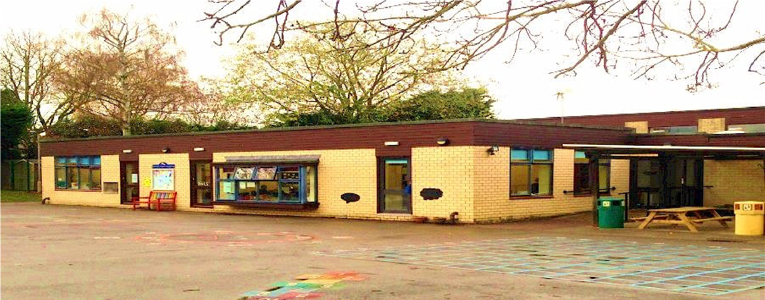

Charging Policy

Date of Review | April 2026
Next Review Date | April 2027
Staff Responsibility | Head
Responsibility FGB/Committee | FGB
Governor Approval

Introduction
All education during school hours is free. We do not charge for any activity undertaken as part of the National Curriculum with the exception of individual or group music tuition.

Voluntary contributions
When organising school trips or visits which enrich the curriculum and educational experience of the children, the school invites parents to contribute to the cost of the trip. All contributions are voluntary. If we do not receive sufficient voluntary contributions, we may cancel a trip. If a trip goes ahead, it may include children whose parents have not paid any contribution. We do not treat these children differently from any others and payment contributions are confidential.

If a parent wishes their child to take part in a school trip or event, but is unwilling or unable to make a voluntary contribution, we will allow the child to participate fully in the trip or activity following discussions with the parent/s or carers. Sometimes the school will make a contribution to the cost of the trip in order to support the visit. Parents have a right to know how each trip is funded. The school provides this information in the information letter sent to parents. Parents may be given the opportunity to pay in instalments if that is helpful and means the trip can go ahead.

The following is a list of additional activities organized by the school, which require voluntary contributions from parents. These activities are known as ‘optional extras’. This list is not exhaustive:
- visits to museums;
- sporting activities which require transport expenses;
- outdoor adventure activities;
- transport for swimming lessons in Key Stage 2;
• visits to the theatre;
- musical events.

Residential visits
If the school organises a residential visit we will make a charge to cover the costs of board and lodging, and travel costs. We will always give parents plenty of notice and give them the opportunity to spread the payments over a period of time. If parents are unable to meet the full cost of the trip we will ask them to make a contribution based on their individual circumstances. This will be discussed and agreed with the parent at the time of booking the trip to ensure that the school does not incur additional unexpected costs for the trip.

Music tuition
All children study music as part of the normal school curriculum. We do not charge for this, and it is taught by non-specialist teachers during normal school hours.

There is a charge for individual or group music tuition if this is not part of the National Curriculum. The peripatetic music teachers teach individual or small group lessons, these are charged separately by the provider, and will be agreed and paid directly between the provider and the parent/s or carers. Terms and conditions will be set out by the provider.

Cancellation fees for individual or group music tuition
To cancel a regular place, a half terms notice is required. Fees will be payable where the provider is not given a full half terms notice of cancellation.

We give parents information about additional music tuition at the start of each academic year should there be any available.

Swimming
The school organises swimming lessons for children in Key Stage 2. These take place in school time and are part of the National Curriculum entitlement. We may charge for this activity due to costs incurred for transport, qualified teachers and lifeguard services. We inform parents when these lessons are to take place, and we ask parents for their written permission for their child to take part in these, along with a contribution to the costs involved. The contribution will vary according to costs involved and the number of children taking part.

Before and After School Activity Clubs
The school offers a variety of additional activities both before and after school. If the coaches are qualified in their field and are not a member of the school teaching staff, the club organisers will make a small charge for these, typically around £3 to £4 per session. On some occasions the school may support the cost of these sessions to enable participation dependent on individual needs and circumstances, this will be through discussions with parents.

We are able to provide a ‘Before and After School Club’ each day for regular and adhoc use. The cost of using this service are:
• | £4.50 for breakfast club | 8am – 8:55am
• | £4.50 for after school club | 3:20pm – 4:30pm (without snack)
• | £7 for after school club | 4:30pm – 6pm (with snack)
• | £10 for after school club | 3:20pm – 6pm (with snack)

• A late collection charge of £10 for every 15 minutes after 6pm will be charged.

A variety of hot or cold snacks is offered after school for those children who are there beyond 4:45pm

Fees for places attended will be invoiced once a month and are payable within 28 days on receipt of invoice.
Fees can be paid by electronic transfer, cash, childcare vouchers or cheque (payable to Pinchmill Primary School). Fees are non-refundable.
Fees are charged for attended sessions.
A late collection charge of £10 for every 15 minutes after 6pm will be added to your next invoice if you do not collect your child by 6pm.
We do not offer a sibling discount.
Staff do not pay for the before/after school club provision if their child attends.

We do not have any cancellation fees as the service remains on a needs must basis for all families. This will be reviewed should the provision ever be running at a loss or we become oversubscribed.

Non-payment of fees
If fees are not paid, the school will write to the parent or carer, requesting payment. If the parents or carers are having difficulty making the payment on time we recommend that they discuss with the Head Teacher as soon as possible to arrange a payment plan.

Where there is no explanation for repeated late payment, the Head Teacher will contact the parents or carers to discuss payment options. A formal warning in writing may be issued to the parent or carer, informing them that continued late payment will result in their child’s place at the Club being withdrawn.

If the fees remain unpaid after all the above options have been explored, the school will not accept the child in the breakfast or after school club until the balance is settled.

Nursery Fees
We now offer a Nursery/Pre-school facility for children of two years and above to Starting School age.

Nursery sessions are charged at an hourly rate of £7 per hour and children are able to attend a number of different sessions:
• | 9am – 12pm | £21
• | 9am – 1pm | £28
• | 12pm – 3pm | £21
• | 1pm – 3pm | £14

If parents or carers would like their child to attend at other times this can be explored through a discussion with the Head Teacher.

Non funded children can also stay for story time from 3pm - 3:20pm where an additional £2.33 will be added on to their bill.

For those in receipt of 15 hours of full-time funded hours, anything over this is charged for accordingly.

For those in receipt of 30 hours, 9am – 3pm parents are charged £2.33 for every day their child stays until 3:20pm

Sessions are charged for whether the child attends or not, whether it is due to sickness or holiday unless there are extraordinary circumstances, this will be at the Head Teacher’s discretion.
Refunds/credits cannot be given for missed sessions.
Fees for places attended will be invoiced once a month and are payable within 28 days on receipt of invoice.
Fees can be paid by electronic transfer, cash, childcare vouchers
We do not offer a sibling discount.
We require one calendar months’ notice for withdrawing your child from the nursery/preschool.

Date of Commencement of Policy: April 2026

Date of endorsement by Governing Body:

Review Date: APRIL 2027

