I said something. Level 1  My partner said something.   | I said something. Level 2  My partner said something.  Then we said more.  
We talked back and forth. Level 3  We asked questions.  We added onto thinking.  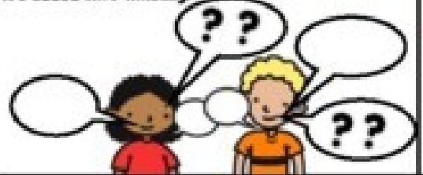 | We talked back and forth.  We asked questions. Level 4  We added on AND  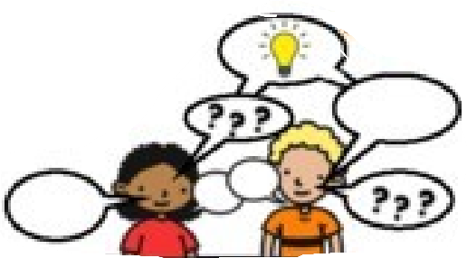  came up with  NEW IDEAS!

